If I have a big url which I want to make shorted and provide to user, I can go to tiny url. I put there the long url and create my own short url to send to user. For instance it will look like this: tinyurl/prg-camp-2018

Seperate solutions.

**GREENFOX ACADEMY**

Visual studio code

Google chrome

Git

**HTML, CSS**

Ked kliknem pravym na stranku tak sa mi zobrazi „Vies page source“ -> mozem zobrazit kód

HTML element - > html subor (neni to textak) a vsetko co dame do zobacikov <> je html element

Html element, head, meta, link element napriklad. Element consists of html attribute e.g.lang and html value e.g. „EN“ In total <html lang=“en“>

Space or new line is never consider for a code, you need to use a **tag.** Tag for a new line is **<br>.** In this form the tag is empty tag, because there is no text in between the open tag and close tag.

**Core elements**

H1-h6

H1 – Header (title) h6 (najmensia z podkapitol)

<h1>Hello world</h1> Header tag is having open and closing tag. Closing tag is always having /

All the other headers work the same (h2, h3 etc). Header one is having the biggest fond and the lower levels smaller font. Header always start on the new line, because header is a block (neco jako obdlznik, ktory siaha na celu sirku stranky, keby sme ju vyfarbili, tak bude cela farebna).

<em>hello</em> is used to emphasize the font and change it to italic.

**Nesting**

I can put one html element into another html element

<h1>hello <h2>world</h2></h1>

**Tag p as paragraph**

Tiez ide o blok, takze je na celu sirku obrazovky.

**Tag a for creating a link**

It has to have at least one attribute. Attribute starts with href=““. I put inside the brackets the link e.g. <https://www.e15.cz/>

V tomto pripade slovo text sa stane hyperlinkom a ked nanho kliknem bude ma navigovat na danu stranku: <p>This is my <a> href="https://www.e15.cz/">text - content</a></p>

**Tag img for picture**

We need a source and the attribute for that is src=“https://www.e15.cz/archive/fpf/47/2018/2018-10-25/0“> I can put there url or folder

**Tag ul for unordered list**

e.g.

* Chapter one
* Chapter two
* Chapter four

**Ak kliknem v chrome pravym a stlacim „Inspect“ zobrazi sa mi kod daneho UL elementu.**

**Do UL vkladame listy LI <li>. Mozeme tiez mat OL – Ordered list (ocislovany, nie s bodkami napriklad), do ktoreho tiez vkladame listy.**

<ul>

<li>my first list item</li>

<li>my second list item:

<ol>

<li>first list item</li>

<li>second list item</li>

</ol>

</li>

</ul>

h2*3

It will do in the end



Using alt button I can move the tag up and down. Using shift+alt I can multiply it

**DIV tag**

It is a box, container I can put anything inside. H1 and p1. I can then form them together with font for instance.

**Semantic elements**

Html je v principe iba text, jednoduchy bez stylu, mozno okrem nadpisov – headerov.

Napriklad <article> Je to lepsie pre google search, lepsie ako **div.**

**Ak zvyraznim tag, visual studio mi ponukne vysvetlenie.**

Celkovo article je tiez iba container pre nieco.

**<header.**

**<nav>**

**<section>**

<article> <aside>

<footer>

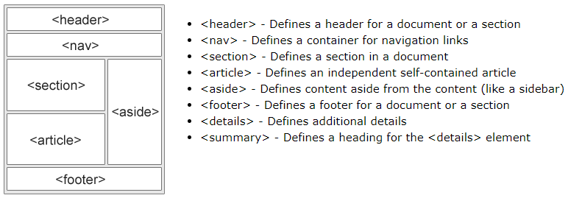

**Attributes**

Image has src, the a tag has href attribute.

**Anatomy of HTML document**

Kazda stranka zacina otvaracim html a zavieracim html.

**Comments**

Nejde o kod, ale o text pre developerov

**Forms**

Su to formulare – napriklad prihlasovaci formular

Form  
Input – I can put there anything, date, password. (v googli to najdem ako input for passwrod for instance) **Dobre su stranky MDN alebo W3**

We write it as

<input type=“date“>

Input type=“password“  
Textarea – multiline text  
Label – združuje, groupuje, napriklad input (heslo) s radiobutton alebo checkboxom. Je to dobre, lebo check box sa zobrazi ako zvyrazneny nie len ked kliknem na maly check box, ale i na text.

Button  
Fieldset  
Legend

**STYLING**

Html tag and everything is inside it. Each html has two parts HEAD and BODY.

Content is in the body

Head contains the meta data. What is the page about, what is the style sheet.

Stylu mozem definovat linkom cez css subor alebo priamo v html cez tag <style>

Ak to robim druhym sposobom tak vzdy zacinam tym, co chcem stylovat – vacsinou cely subor, ciez html.

**Core properties**

Padding

Border

Color

Background

**Inside the styles we DONT use anymore <> BUT** {} a ukončujem s ;

Margin

Height

Width

Hitting Control+space, I get many tags as align etc.

HTML elements are ussually considered as boxes. If I inspect the web page and highlight the code, usually it will highlight the contect as box.

Box model has three parts: We can see it in the inspection in very bottom if we scroll down the code of the web page.

**Margin – outside part, how far the other parts – text should be from the margin**

**Margin: 20px 30px 40px 50px (upravuje margin v smere hod ruciciek) alebo napisem margin-top:20px a tak dale) To iste plati pre border!.**

Border – inside a margine

Padding – insdie the border

All above can be seen in css.

**To specify a border you need to specify three things or google it:**

How bit it will

Border:2px solid black; seperated by spaces

**Font-size**: 24px

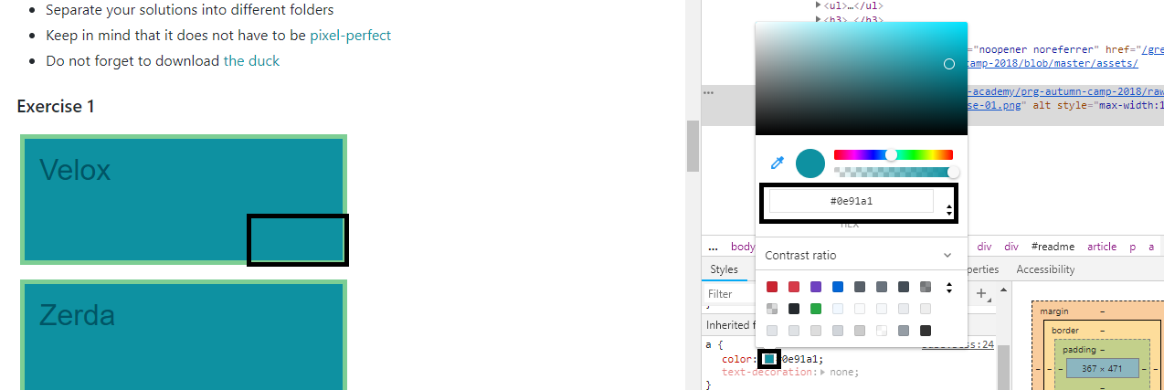

**Cvicenie cislo 3**

Ciel je to urobit jednoducho, co sa mi nepodarilo, fungovalo to ale zlozite.

Zaciname html, head, body. V tele mame obsah – div (boxes). V hlave mam styly. V **div** si mozem vytvorit classy, na ktore sa v style odkazem, aby som zbytocne nekopiroval rovnake veci.

Mozem mat velky div a pod nim styri male napriklad.

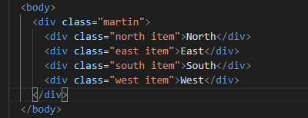

V Hlave sa odkazem na classu Martin (velky box), ktory bude mat definovane parametre.

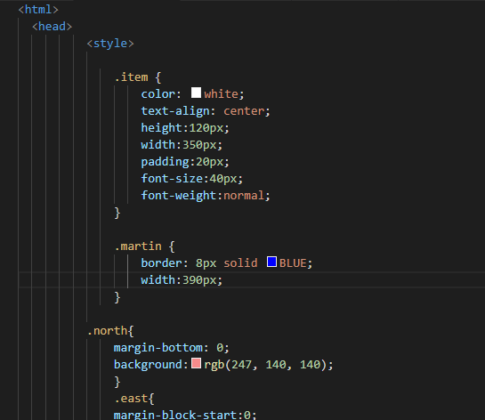

**JAVASCRIPT**

MAINLY programming lang of the web.

<script> tag i sused to insert a code. In betweeen you can write the code to be read by the browser.

Javascript is not a replacor of java. Java was for desktop application, like skype, excel – all desktop apps. Javascript is for software creation to manipulate the web – mainly html.

**Declare variables and assign values. There are certain types of data**,**operators.**

**Variable**

Variable is being created like:

Let myVariable;  
myVariable =42;  
let myAnotherVariable=42;

You can put any type in it – integer, string.

**Console.log()**

To display in very easy way something what you do in terms of coding. I can activate the console by rightclicing on the web->inspect->press console. Everything I type there is log in console. The comman itself means, it will do some action

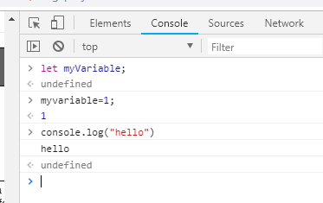

If I do not use quotation marks, the program will consider it for **variable.**

**Data types**

**It can be number, string – or text.**

**String**It does not matter which quotation mark I use – double, single or apostrof.

Let greeting = „hello“;

Console.log(greeting);

I need to seperate the code by enter, otherwise it iw syntax error.

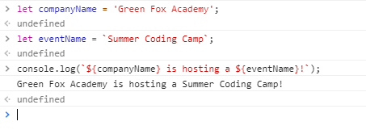

For above example, if I want to **concatenate more variables,** you need use **`symbol always before $,** otherwise you can use any other quotation marks „`‘

**Number**

Let days=3;

**Boolean**

Let learing = true;

Let hunger = false;

True or false variable for comparision.

**Array**

Let mentors = [´Arnika´,´Aze´];

Console.log (mentors[0]);

Console.log (mentors[1]);

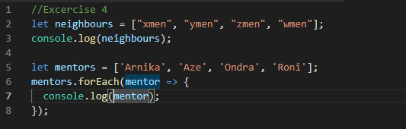

Above code will list the array either next to each other or below each other.

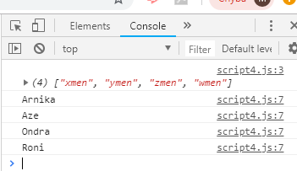

If I want to add any text to the looped value then:

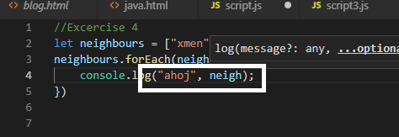

**Object**

Let company – {name: “Green fox academz”,address: “Ändrassz street66”};

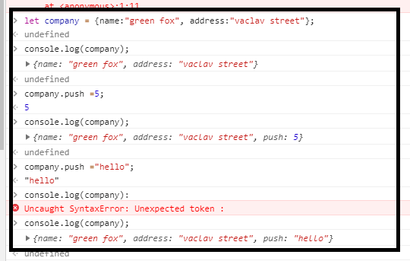

You can push a number or string (text) to the variable object. Object consists of two or more information to display.

So far we have shown the ways of how to store the data.

**Comments in java script we can do with //**

It will be greyout.

**Operators**

What can we do with numbers

Addition,+ (i can do 1+1, 1+myVariable, “hello”+”me”)

Substratction,-

Multiplication,*

Division,/

Assignment, =

Equality,+++

Not,!

Does not equal, !+++

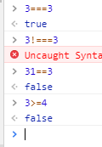

**Conditionals**

If if ...else....elseif

letiHadCoffee = true;

if (iHadCOffee) {

console.log(ï am coding!”)

} else {

Console.log(

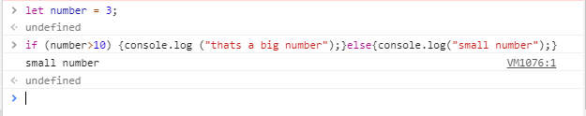

Using **if** and **forEach**

I define variable, in the case below the neighbours. And then I define variable for the loop

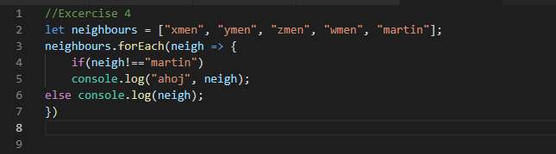

**Simple brackets contains condition and the curlz brackets action**.

**Loops**

Loops in array until a condition is met

Array.forEach(item=> whatToDo)

**ForEach** means I want to repeat something for everything in the array.

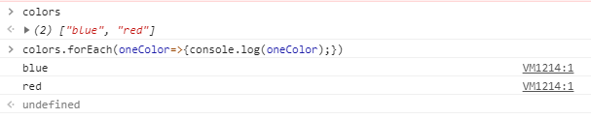

How to run it from file not console. I will do it from visual design where I create html file which I will reference to java file e.g. script.js

To **find even** or **odd numbers in a LOOP forEACH**, we lookp in a array and do it the below way.

The result will be like this

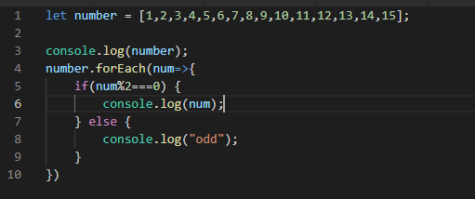

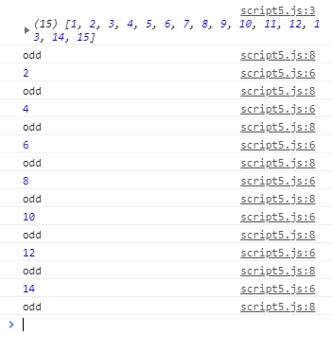

**If statement.**

If there are more if statements (without else) program checks each of the IF in the LOOP and keeps the VALUE of the previous IF. **It does not delete it. Therefor if three IF is TRUE it will return three times TRUE, it will not return just the last IF.**

If the first **IF** with using **ELSEIF** is met, it will jump out from the loop and not consider other elseifs.

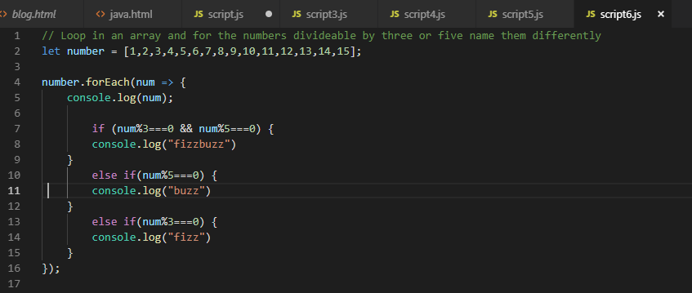

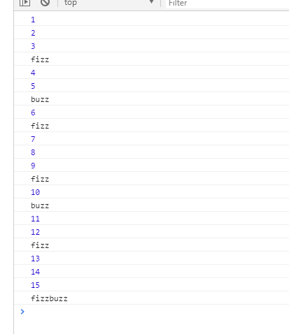

**DAY THREE**

**Jquery** is collection of codes which expands java with multiple things. Instead of five lines of code you can use one for example. Jquery I am sourcing from web or other source. It stored by version, so it will not be overwrite.

You can change the text on the page. Inspect it and find out the element. Like header 2 for exampel.

**Select** we do with $

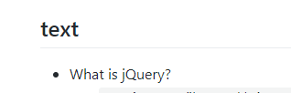



I can **select**  several ul for instance and appent there li with text

**$(“ul”).append(“ <il>add a line<li>”).**

IDs are being selected with hash tag.

**Hide or Unhide**

**$(“li”).hide()** or instead of hide I use **show.**

**Event listener with .on** function

Event is anzting what user do (reads, saves, tzpes etc) E.g. If the user reaches hundered letters in writing message, it iwll stop after reaching a limit.

**$(selector).on(eventType,function):**

$(„li“).on(„click“, event=>{alert(„you clicked on a li.“);});)

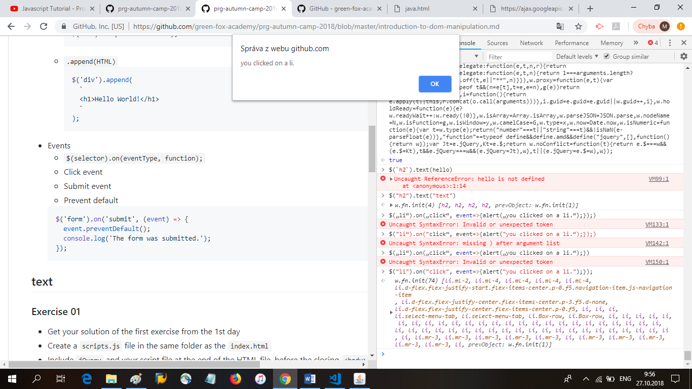

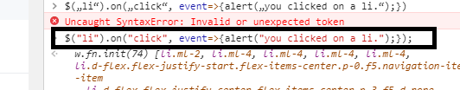

**I**If the user selects a link }tag a].

**Jquery you loose if you reload the page. You can use the jquery if you do not reload the page and you can deleted it with the function clear in the console.**

**Event types**

Click, submit, prevent default

$(„a“).on(„click“,(event)=>{event.preventDefault();console.log(„the form was submitted“);  
}):

Same like we changeed content we can change the style.

$(„li“).css(„background“,“orange“) I select li and in css I change the backgroundn to orange.

I can **change multiple objects**.

**Let** myChange = {**background**:“purple“,**color**:“white“}

**Event append**

Then i can put it to query instead of background.

.text() .css() .on(„click“) .on(„mouseover“)most useful queries.

**Event**

**Below i have statement which events to list on <li> i clicked on but also names the exact line i clicked on. That is triggered by event.target**

$(„li“).on(„click“, (event=> {alert(„you have clicke on „+$(event.target).text()));

In the html I need to first put the script of jquerz and then the javascript otherwise it will not work.

If I am refering to **ID** in the html like for instance <h1 id=“fox“> in the **js script** I will write it like this. I need **to use #**



If I want to change the **styles** I will do it with the **event caller css.**

**If I want to add CLASS** in the html I use **. instead of #.**



In the **css styles** I can see the name of the styles.

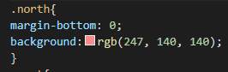



**Append**

If I have an **array** and I loop the **array** with **forEach.** I want to put the names in the array to <ul> lists.

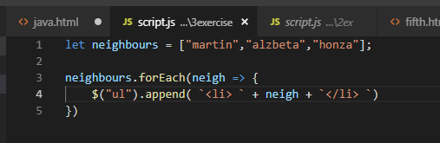

It will look like this.

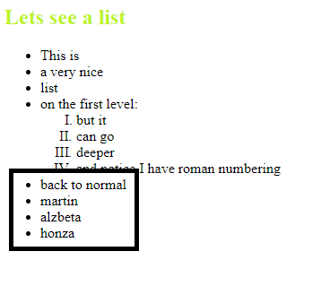

**forEach** in **jQuery** looping in Object and array and do **append.**

Basically I select either ul or body and appened in the end (append always add to the end) new tag: either header, paragraph or list. Everything I put in between is the text of the newly created tag. I connect them with +.

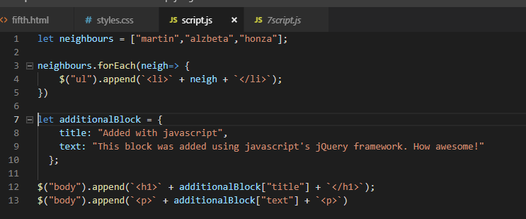

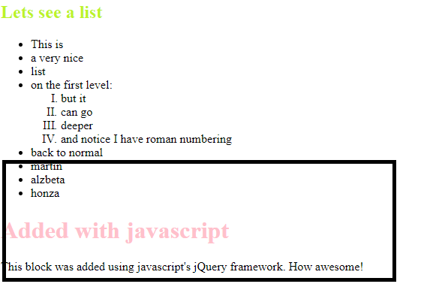

I trigger an **event** when user clicks on the button and the counter increases.

**Animations with jQuery**

Before starting I need to write the $(function) and then do typical select and do animation action, including .show or .hide

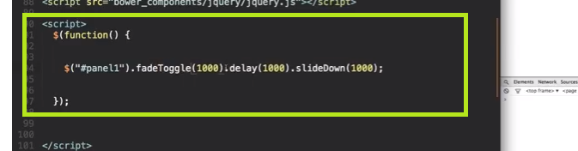

Mozem tiez urobit objekt menej viditelny – priesvitny.

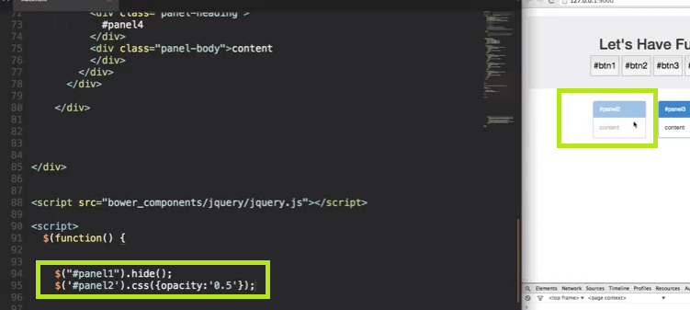

**Event** moze ovplyvnit chovanie stranky.

Selectujem panel 1 (# je tam kvoli tomu, lebo blok panel jedna je referovan ako ID). Cez funkciu html ovplyvnujem cele html a menim text, font etc.

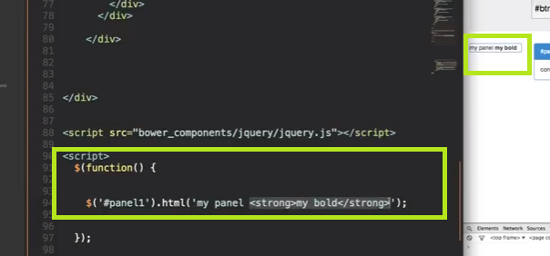

Event dole hovori, aby sme vybrali button jedna a na click urobili akciu. V nasom pripade selektuj panel jedna a stiahni ho za dve sekundy.

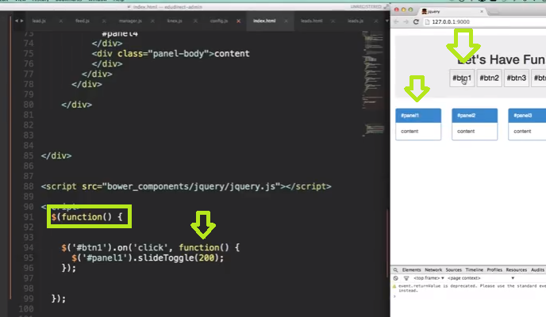

**Saving and loading a page**

**My jQuery** should be last, before than **jQuery** and then

Before that i put script of the firebase.

In Firebase, create a database, start in test mode.

Two dtb to create, suggest to use Realtime dtb. / in firebase change it from cloud to realtime.

Click on the rules in the firebase dtb. Change it there as written in the instruction of greenfow. It should allow me to write to database.

In html we should create a firebase shortcut. Put it in the script of the html.

**Saving a new post**

Data has a path where they are stored.

Create variables as suggested and put them in your script.js

Title:$(„#title-input“).val(),

Then we will reference the path and set the data to database.

Then we can check in the Firebase database the posts will appear.

initialData.forEach(post =>{$(„body“).append(„<h1>${post.title</h1> <p>${post.text}</p>

above loads dta from script. To load it from database go to the instruction of loading existing posts.

Replace the initialData with savedPosts.

Fb is firebase

.once function means whenever the data arrives from database .thne we want to use it.

**Deploy the blog and put it online and make it available to everyone.**

We will use git hub which stores files and the coe is couple of files.

It is intergrated with visual studio.

In VS go to

The html should be named index.html

In the left tool bar is a button source control